Assignment 1 Data Visualization
Contents
Assignment Requirements ...................................................................................................................... 2
• Cover page ............................................................................................................ 2
• Table of Contents ............................................................................................................. 2
• Main body .................................................................................................................... 2
• A reflective .............................................................................................................. 2
Assignment 1 Data Story Telling ..................................................................... 3
Scenario .............................................................................................................................. 3
First Task ............................................................................................................. 3
Policies and Procedures ................................................................................................... 3
Second task............................................................................................................. 3
Excel ...................................................................................................................................... 3
The data ................................................................................................................................. 3
Third Task ........................................................................................................................... 6
Tableau ................................................................................................................................... 6

Requirements
Your first assignment will be covering your training for the last few weeks 1 to 2:
1. Data and Data Structures
2. Development of Data sets using Excel
3. Introduction to Tableau
You will be given a scenario and a list of tasks that you will need to cover in order to complete your first consolidation project. There are certain requirements that you should follow when producing your project and they are as follows:
• Cover page including the title of your project, your name, and the date of submission. 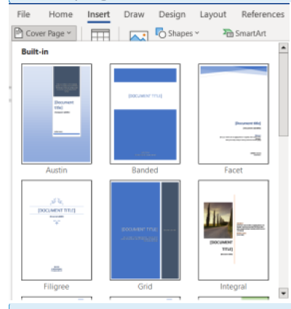
• Table of Contents to direct the reader to each individual section of the report

• Main body of your report should include screen shots of your process throughout the project with a detailed definition of the image. This is to help us evaluate your learning understanding.
• A reflective account to evaluate your project, including what went well and areas for development and lessons learned.

Scenario
Data visualisation has become an essential business capability to help transform information into insights that can drive meaningful business outcomes and improved experiences. Today, most organizations have accumulated a wealth of data from the different corners of their businesses they are then unable to see how this data can help them make better decisions, making actions, and results.
You have been asked to Look at the data workbook and familiarize yourself with this data. You have also been asked to create a visual report that will show the data in the form of charts and maps using Tableau to the client requirements. You will also need to consider data protection and computer misuse policies.
First Task
Policies and Procedures
The first part of your assignments will be to outline what policies need to be adhered to when working with data.
You are going to be working with ‘The Wealth of nations’ data. Investigate by researching the internet or looking back at your notes to tell us what and why these policies need to be adhered to while you are using this data. Also tell us why it is important to be aware of these rules as a data analyst .
Second task
Excel
You will be working with ‘The Wealth of nations’ data which is in the class materials folder

The data
Open the excel table and familiarise yourself with its content. You will notice that there are three tabs. We will be working with the first tab GDP for the excel work.
GDP Tasks
1. Set a password to protect the workbook
2. Highlight column C and change the data to display in British Pound symbol
3. Turn the GDP sheet into a table.
4. Filter the table to display only the information for 2019
5. Next create a chart that will only display the following data ‘Rank, Country and GDP - per capita (PPP). The chart can be anything as long as it is suitable.
  - 6. Using your creative skills edit the chart a. Add a title
  - b. Add X and Y axis labels
  - c. Make the chart visually pleasing
7. move the chart to a new sheet and add a suitable name
  - 8. Create a sort for the top 20 highest ranking counties
  - 9. Next create a new Bar chart to display the 20 highest ranking countries from your sort and then move the chart to be underneath the table, as shown below.
  - 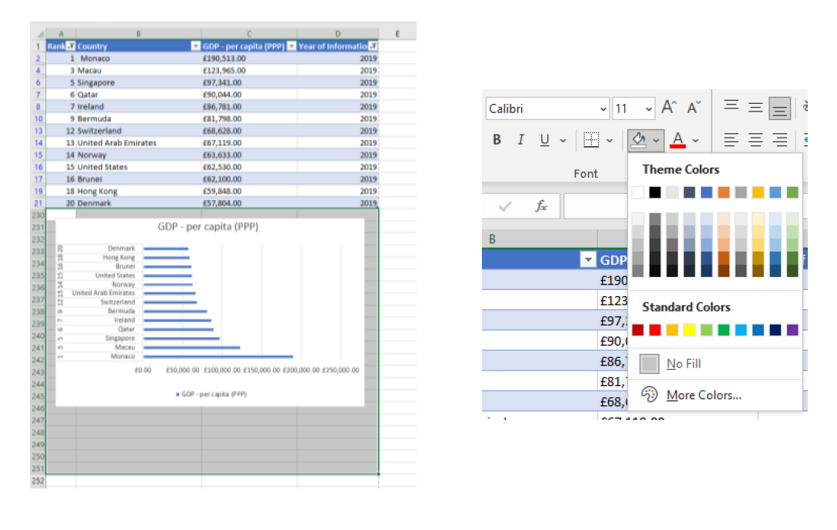
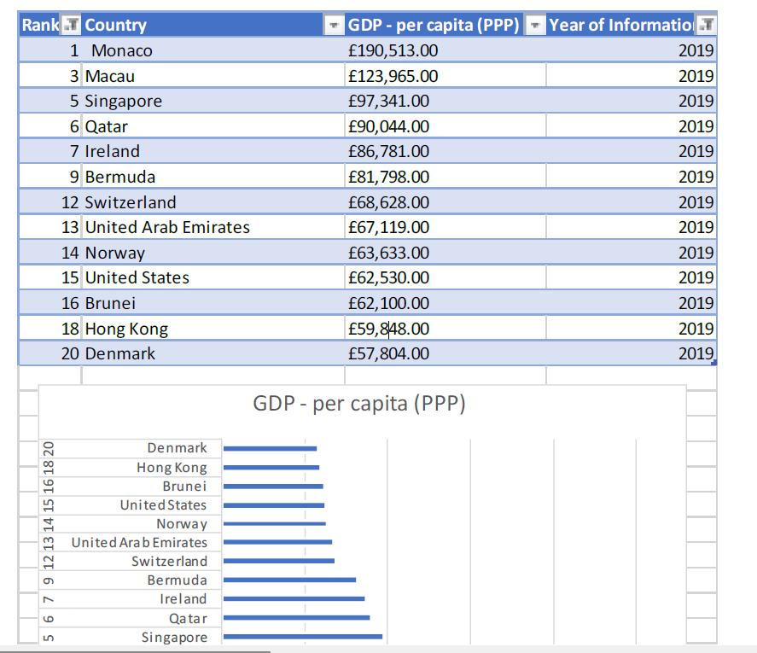

10. Colour the background by highlighting the area underneath the table as shown below. Find the add a fill colour icon and select a colour.

Third Task
Continuing with the Excel table ‘The Wealth of nations’
Tableau
Remember to follow the workflow that we used in the workshop, as seen below:

1) Import data
2) Set relationships:
You have three sheets and the common column for all of them is country, so the visual arrangement of the sheets does not matter Only the columns that you use to create the relationship matters. You can arrange the sheets in a straight line as seen below:
Or you can arrange it like this:

3) Check data types.
4) Build charts
You are now ready to create charts. Please make sure to create at least 4 visuals. There is no upper limit.
Client Requirements
The client is colour blind and requested you to bear this in mind when building your dashboard. The client is only interested in the top 20 highest ranking countries. All your visuals should be for the top 20 highest ranking countries.
5) As you create your charts, if you see a little grey box containing a count of null values, select the filter option.
6) Build your dashboard.

